Q1: Write a function that can remove duplicates from circularly doubly linked list.

Question 02

Being an extra ordinary student in Data Structures, your teacher wants you to write a code to convert

algebra postfix expressions to infix stored in a linked list. Each node should have a Boolean variable

that shows if the data is an operator or not, a character data that stores the operator or the operand in

it and a link to the next node. Write a function Postfix2INFIX () that receives a inked list as an argument

and returns its rearranged version.

Note:

● No need to write a separate function for insertion, you can create a few nodes and link them in

your main function.

● Length of the expression and length of the linked list is not fixed. @ denotes end of one

expression.

● For the sake of simplicity, all operators hold same precedence.

Initial List:

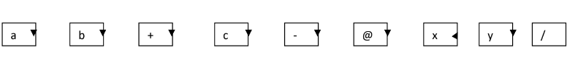

a b + c - @ x y /

After rearrangement:



Question 3: Create a directed graph and detect the cycle from that graph.